Khizra Noor

Sap id: 55124

Coal lab # 7

Task : 1

Write an assembly language program that find the square of a number entered by user. Print the result on screen.

Program

.model small

.stack 100h

.code

main proc

; Read a character from the user

mov ah, 01h

int 21h

sub al, '0' ; Convert ASCII character to a number

; Calculate the cube

mov bl, al ; Store the original number in BL

mul al ; AL = AL \* AL

; Display the result

add ax, 30h ; Convert the result to ASCII

mov dl, al

mov ah, 2

int 21h

; Exit program

mov ah, 4Ch

int 21h

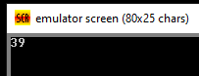main endp

end main

Output

Task : 2

Write an assembly language program that find the cube of a number entered by user. Print the result on screen.

Program

.model small

.stack 100h

.code

main proc

mov ah, 1

int 21h

sub al, '0'

mov bl, al

mul al

mul bl

add ax, 30h

mov dl, al

mov ah, 2

int 21h

mov ah, 4Ch

int 21h

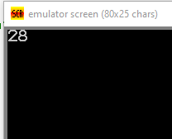main endp

end main

Output

Task : 3

Perform multiplication of two numbers entered by user. Print the result on screen

Program

.stack 100h

.model small

.data

num1 db 0

num2 db 0

result db 0

.code

main proc

mov ah , 1

int 21h

sub al , '0'

mov num1 , al

mov ah , 1

int 21h

sub al , '0'

mov num2 , al

mov al , num1

mul num2

mov result , al

add ax , 3030h

mov dl , al

mov ah , 2

int 21h

mov ah , 4Ch

int 21h

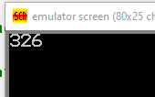end main

main endp

Output

Task : 4

Write an assembly language program that finds the area of a triangle

Program

.stack 100h

.model small

.data

base db 0

height db 0

result db 0

.code

main proc

mov ah , 1

int 21h

sub al , '0'

mov base , al

mov ah , 1

int 21h

sub al , '0'

mov height , al

mov al , base

mul height

mov bl , 2

div bl

mov result , al

add ax , 30h

mov dl , al

mov ah , 2

int 21h

mov ah , 4Ch

int 21h

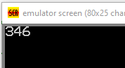end main

main endp

Output